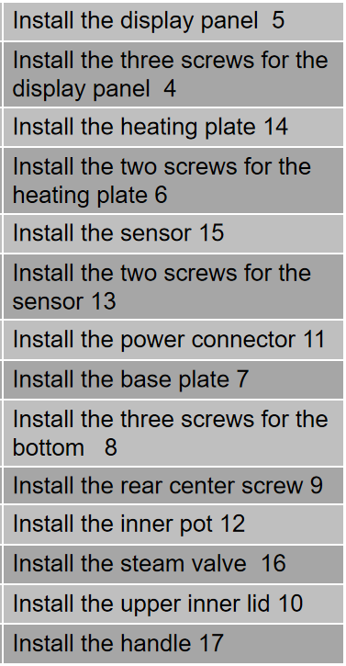

• Step 1:安装显示板 ok
- Action1:安装整体显示板
Object1:整体显示板
- Action2:按压右侧显示板
Object2:右侧显示板
- Action3:拿起整体显示板
• Step 2:取螺丝 ok
- Action5:取螺丝
Object5:螺丝
- Action6:推出螺丝
• Step 3:Install the three screws for the display panel ok
- Action9:安装显示板螺丝
Object9:显示板螺丝
• Step 4:install the heating plate
- Action13:install the heating plate
Object13:heating plate
• Step 2取螺丝 ok
• Step 6:Install the two screws for the heating plate ok
- Action21:安装加热板螺丝
Object21:加热板螺丝
• Step 7:Install the power connector
- Action25:Install the power connector
Object25:power connector
• Step 8:Install the base plate ok
- Action29:盖上后盖
Object29:后盖
- Action30:按压后盖
暂无9（可以设置螺丝机器取螺丝）
• Step 10:Install the three screws for the bottom ok
- Action37:拾取底盘螺丝
Object37:底盘螺丝
- Action38:安装底盘螺丝
• Step 2取螺丝 ok
• Step 12:Install the rear center screw ok
- Action45:安装后部中心螺丝
Object45:后部中心螺丝
• Step 2取螺丝 ok
• Step 14:安装盖板螺丝 ok
- Action53:标记盖板
Object53:盖板
- Action54:安装盖板螺丝
Object54:盖板螺丝
• Step 15:Install the inner pot
- Action57:Install the inner pot
Object57:inner pot
• Step 16:Install the steam valve
- Action61:Install the steam valve
Object61:steam valve
• Step 17:Install the upper inner lid
- Action65:Install the upper inner lid
Object65:upper inner lid
Step 18:Install the handle
- Action69:Install the handle
Object69:handle

4，7，15，16，17，18

• Step 1: Install the display board
- • Action1: Install the overall display board
- Object1: Overall display board
- Action2: Press the right display board
- Object2: Right display board
- Action3: Pick up the overall display board
• Step 2: Pick up screws
- • Action5: Pick up screws
- Object5: Screw
- Action6: Push out the screws
• Step 3: Install the three screws for the display panel
- • Action9: Install the display panel screws
- Object9: Display panel screws
• Step 4: Install the heating plate
- • Action13: Install the heating plate
- Object13: Heating plate
• Step 2: Pick up screws (Repeated)
- • Action5: Pick up screws
• Step 6: Install the two screws for the heating plate
- • Action21: Install the heating plate screws
- Object21: Heating plate screws
• Step 7: Install the power connector
- • Action25: Install the power connector
- Object25: Power connector
• Step 8: Install the base plate
- • Action29: Cover the back cover
- Object29: Back cover
- Action30: Press the back cover
• Step 10: Install the three screws for the bottom
- • Action37: Pick up the base plate screws
- Object37: Base plate screws
- Action38: Install the base plate screws
• Step 2: Pick up screws (Repeated)
- • Action5: Pick up screws
• Step 12: Install the rear center screw
- • Action45: Install the rear center screw
- Object45: Rear center screw
• Step 2: Pick up screws (Repeated)
- • Action5: Pick up screws
• Step 14: Install the cover screws
- • Action53: Mark the cover
- Object53: Cover
- Action54: Install the cover screws
- Object54: Cover screws
• Step 15: Install the inner pot
- • Action57: Install the inner pot
- Object57: Inner pot
• Step 16: Install the steam valve
- • Action61: Install the steam valve
- Object61: Steam valve
• Step 17: Install the upper inner lid
- • Action65: Install the upper inner lid
- Object65: Upper inner lid
• Step 18: Install the handle
- • Action69: Install the handle
- Object69: Handle
Tool 1:记号笔
Tool2: 螺丝刀

